Post –lab questions
- Identify the electrophile and the nucleophile in the reaction
Electrophile –vanillin aromatic ring
Nucleophile-Iodine
- How is the electrophile generated? Write an equation to support your answer.
Electrophilic is generated from a compound that attracts pair of electrons.

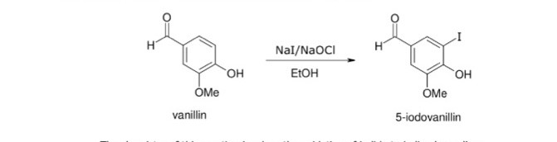
- Product theoretical yield
Ortho-vanillin grams =1.0015g
Moles =mass/molar mass
1.0015/152= 0.007g/mol
Product theoretical yield =0.018
- Product percentage yield
0.007/0.018x100=3.9%
- Write equation of reaction
2NaI+NaoCl +H20 NaCl +I2+2NaoH
- Expected melting points for reactants and products.
Melting points 260 degrees Celsius

